NAU ServiceNow Agent Workspace Configuration

Contents

Watch first

Accessing Agent Workspace

Navigating Workspace

Lists / List View

Form View

Opening a new Incident

Working an Incident

Working a Request

Opening a Request

Notifications

Agent Assist

Custom lists

Other Resources

Watch first

If this is your first time ever accessing Agent Workspace, this video may be helpful before reading the rest of this document.

<https://www.youtube.com/watch?v=z2su-LkweJ4>

Accessing Agent Workspace

* Login to ServiceNow via <https://nau.service-now.com>
* From the left-hand navigator select “Workspace Experience > Agent Workspace Home”

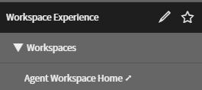

* A new browser tab will open to the Home landing page, which may differ from the image below depending on your role in the system. The landing page can be accessed anytime by selecting the “Home”  icon in the left hand module navigator

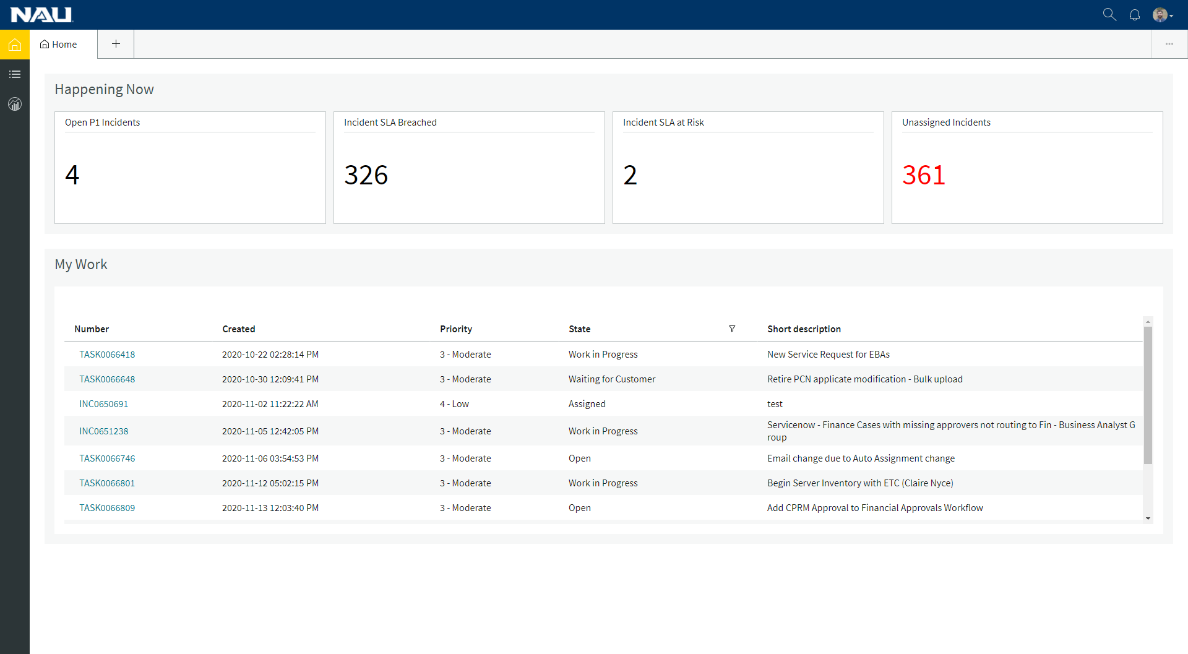

Navigating Workspace

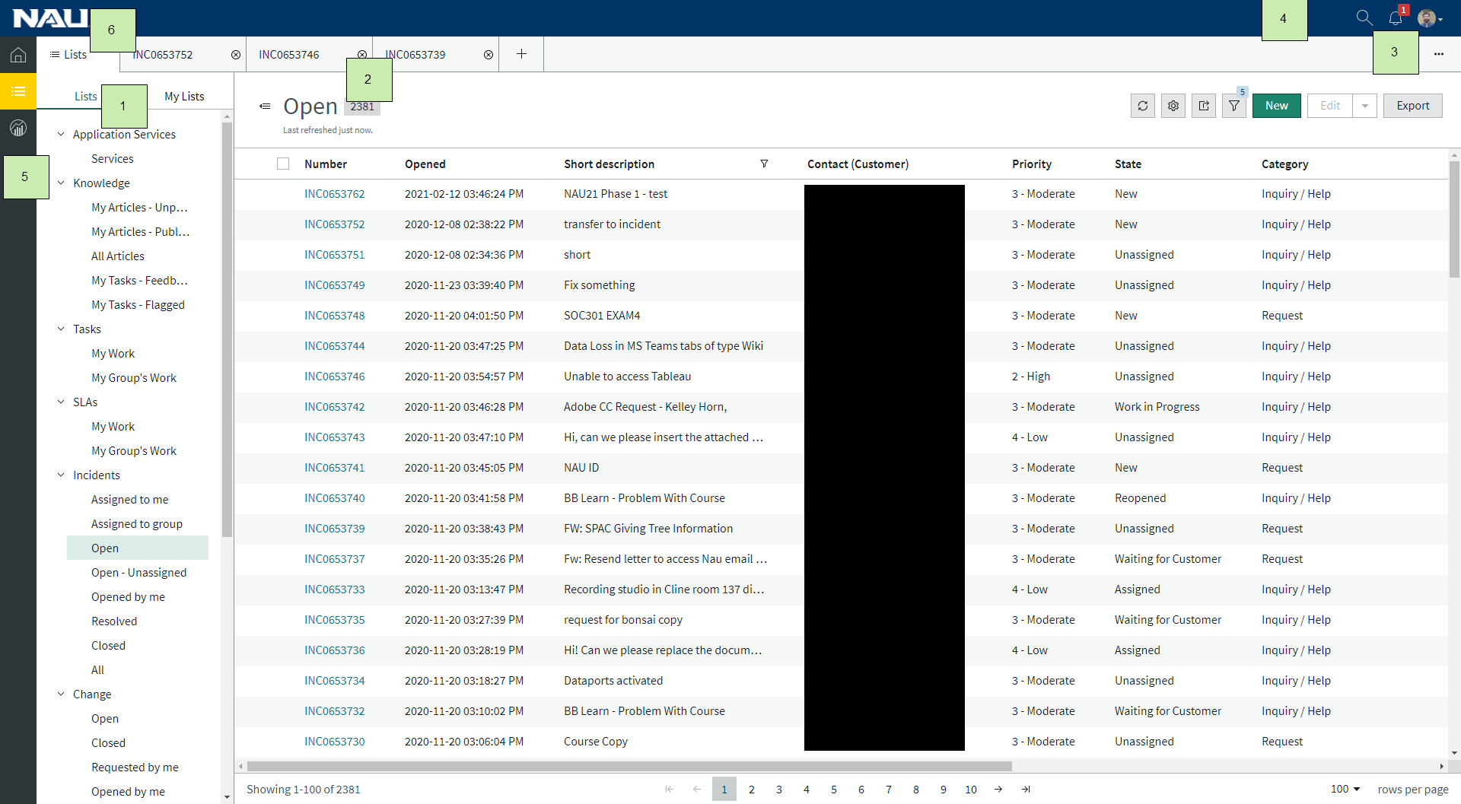

1. Lists: Filters to access records. Agents can create their own filtered lists under My Lists.
2. Tabs: Tabs that allow agents to create and manage many records at once
3. Workspace Notifications: Notifications that display in Agent Workspace when a record is updated or assigned to a user
4. Global Search: Search the system for records
5. Module Navigation: Switch between selectable modules
6. Module Tab: A fixed tab set to the selected module

Lists / List View

Lists, accessed by clicking the “List”  icon on the left-hand module navigator, are predefined filters of data. For example, clicking “Incidents > Assigned to me” will display all active incidents assigned to the agent logged in.

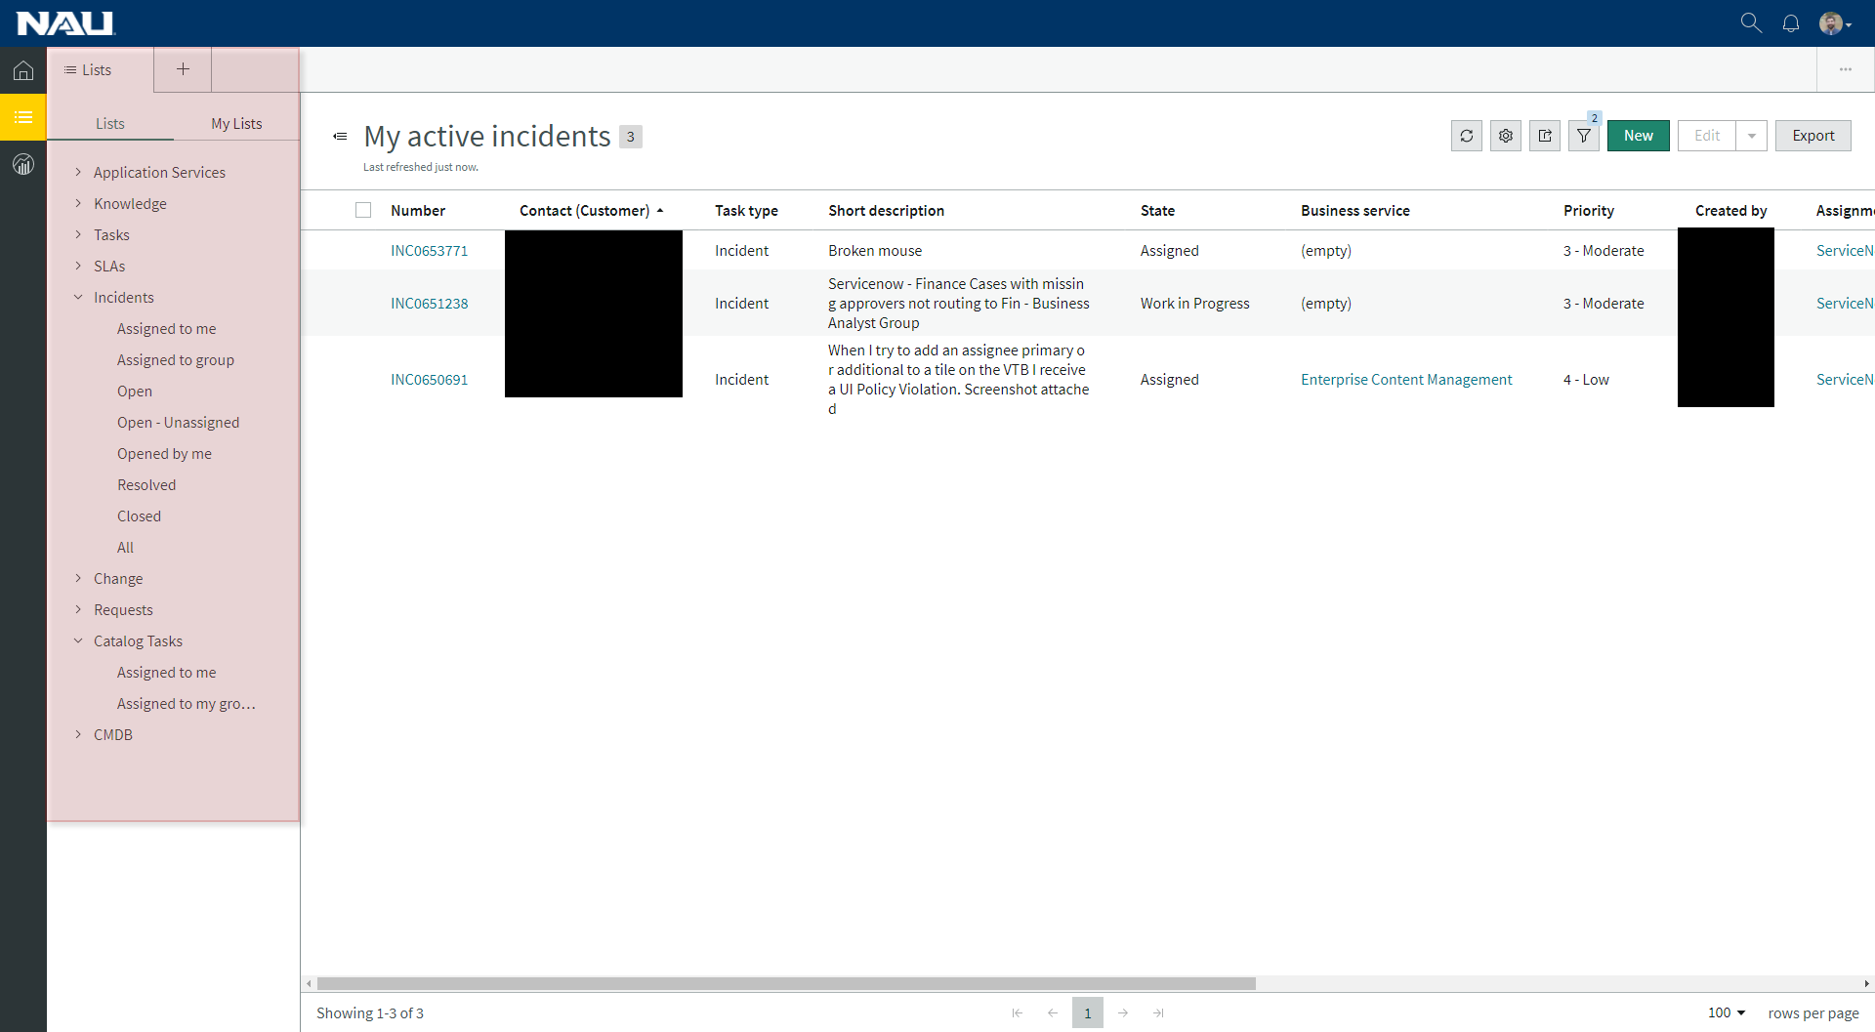

Form View

The Form View displays a single record selected from the list of records via lists. It is composed of: Details, Activity Stream, Agent Assist, Ribbon, Related Lists, and a Header.

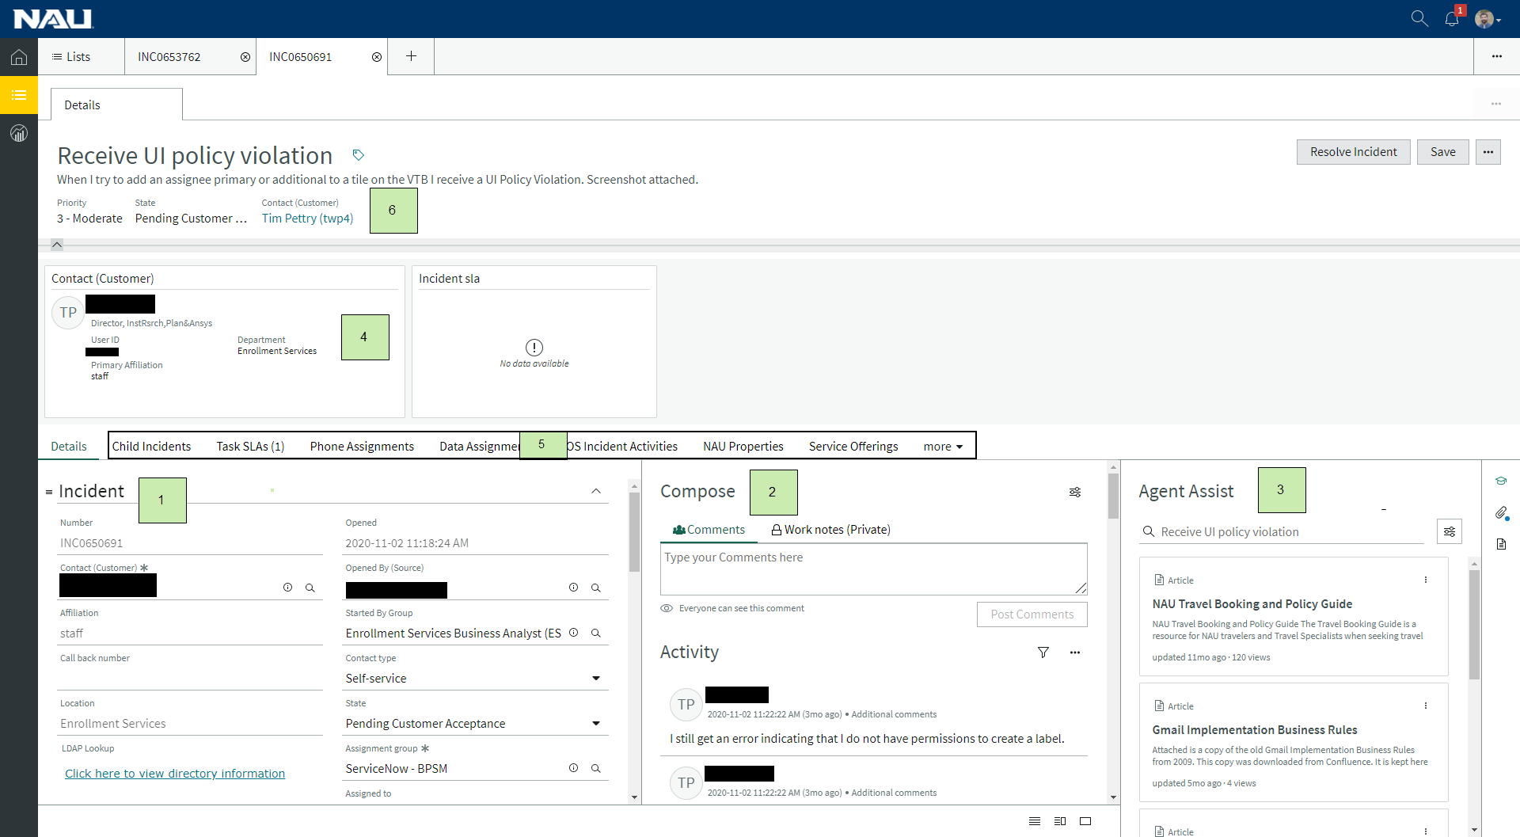

1. Details: Displays the available fields of the selected record
2. Activity Stream: Shows all previous activity of a record, also allows agents to compose comments and work notes
3. Agent Assist: Enables agents to search the knowledge base, incidents, and changes. Also allows for agents to manage attachments
4. Ribbon: Displays data cards
5. Related lists: Displays records related to the selected record
6. Header: Displays details about the select record

Opening a new Incident

Incidents can be open in two different ways, by using the + icon in the top of the workspace in the tabs area

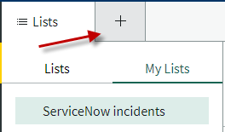

Or by clicking the “New” button from an incident list

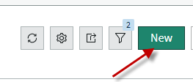

A new tab will open with an empty Create New Incident form. Fill in the mandatory fields (Contact, Service Type, Assignment group, Short Description, and Description) as well as any additional information. Once a short description is filled out, Agent Assist automatically searches for relevant KB articles, as well as any related Incidents or Changes

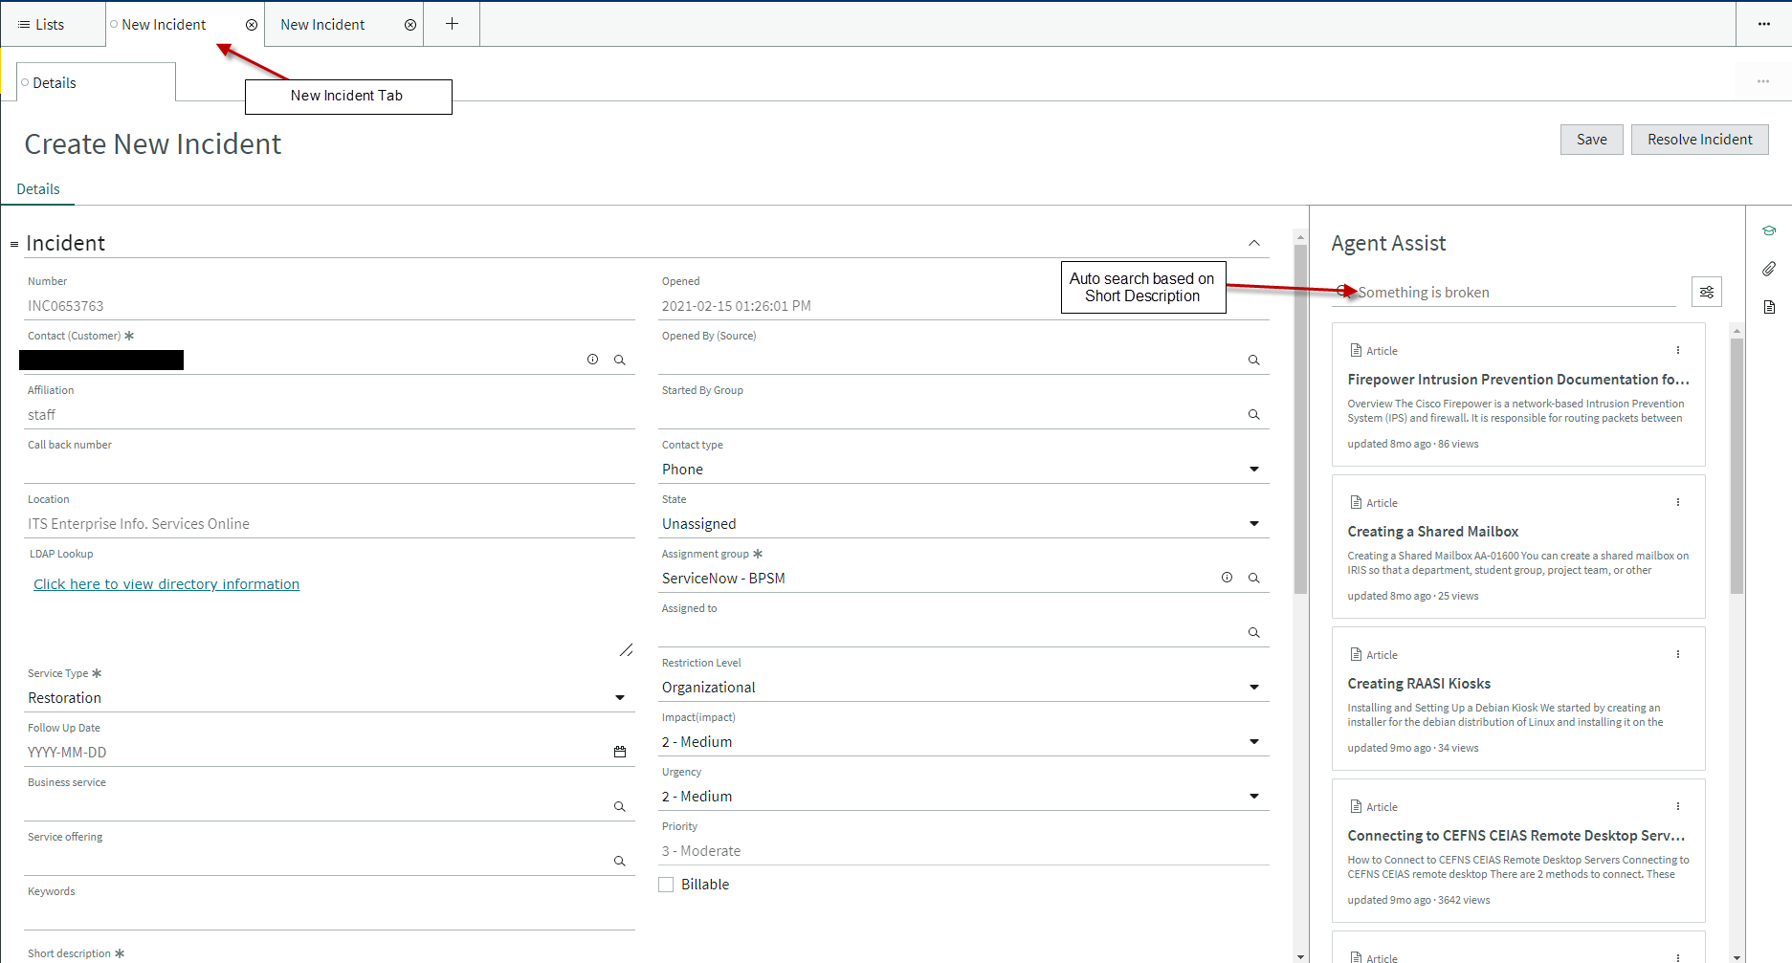

Click Save to create the Incident

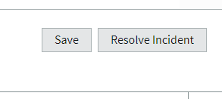

Working an Incident

Form view

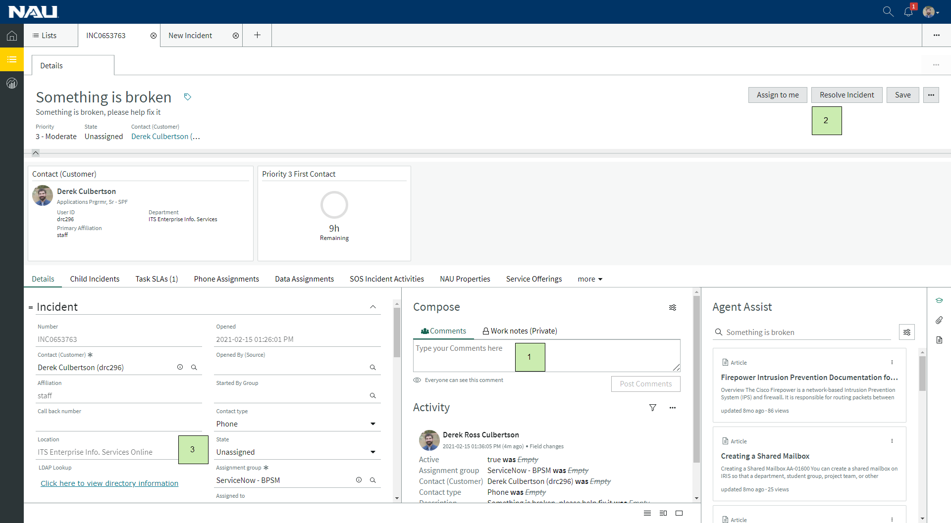

1. Use “Comments” to communicate with the customer or “Work notes” to add notes to the incident. Work notes are not visible to the customer.
2. Use the buttons in the top right of the form to interact with the incident.
3. Use the details form to update the ticket (e.g. Assignment Group, Assigned To, and State)

To resolve the incident, either use the “Resolve Incident” button, or manually change the state to “Resolved” and click the “Save” button. Close code, and Close notes will appear and be mandatory when the state changes to Resolved. Fill in this data and click Save or Resolve incident.

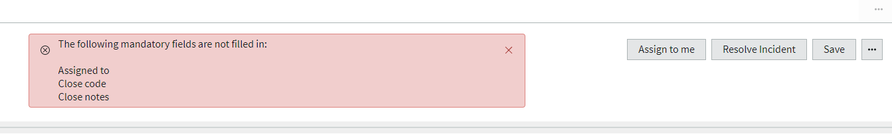

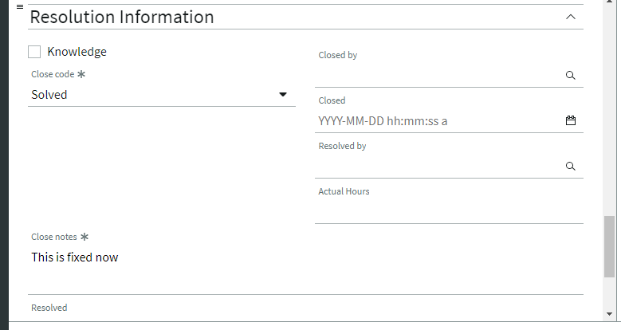

Working a Request

Requests are open via the Service Portal and are not created through Agent workspace at this time.

Use the “Lists” to navigate to “Requests > Open Requests” or “Catalog Tasks > Assigned to me” filter

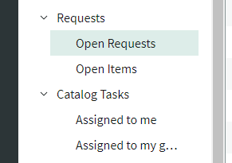

Click the number to open the record that is being worked in the list of records

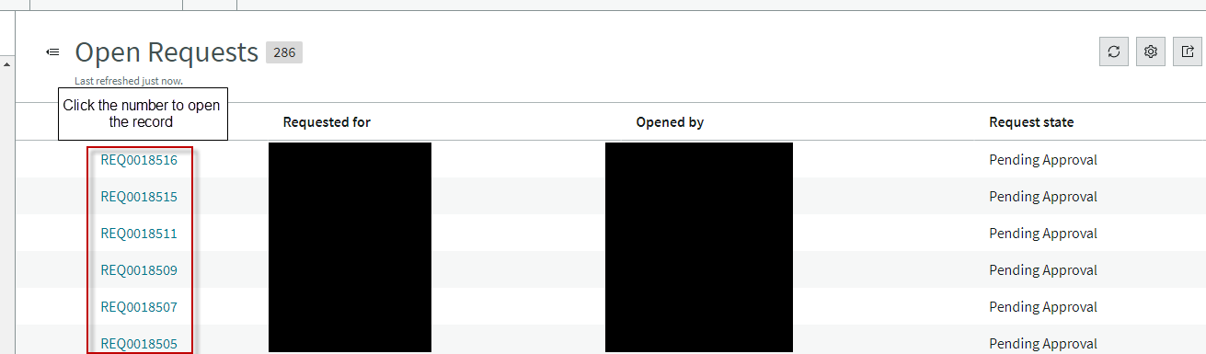

Use the related list to access the related RITM’s, TASK’s, or REQ’s

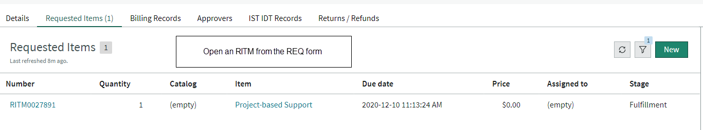

The RITM form will open, from the RITM form agents can open a related TASK

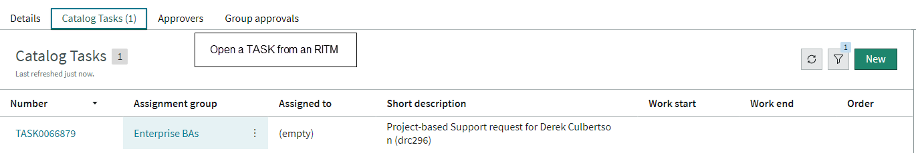

TASK Form configuration

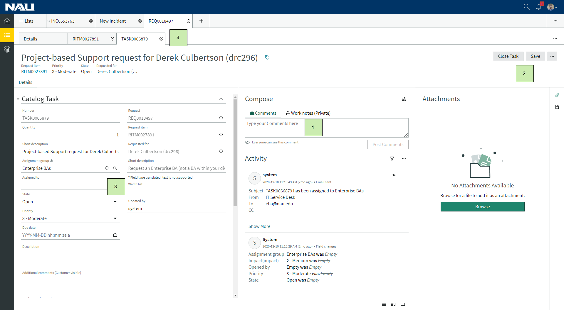

1. Use “Comments” to communicate with the customer or “Work notes” to add notes to the incident. Work notes are not visible to the customer.
2. Use the buttons in the top right of the form to interact with the record.
3. Use the details form to update the ticket (e.g. Assignment Group, Assigned To, and State)
4. Nested tabs, the top tab indicates the Request, and the 3 sub tabs represent the records open via the related lists

To close a TASK, fill in all the mandatory data and any other relevant information, then use the “Close Task” button or change the state to the appropriate close state and click save to close the TASK. For more information regarding Catalog Requests, reference [Using Service Catalog Requests in ServiceNow - Staff](https://nau.service-now.com/nav_to.do?uri=%2Fkb_view.do%3Fsys_kb_id%3D2bb112bfdb820054a9fe92b6db96195a)

Notifications

Notifications can be accessed via the top right hand of the banner by clicking the notifications icons. The system will display a number if there are pending notifications. Currently Notifications are sent to the “Assigned To” when a record is updated, as well as the Watch list and Work notes list.

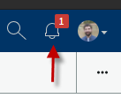

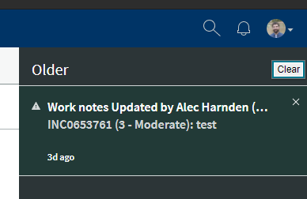

Clicking the notification will open the associated record in a new tab

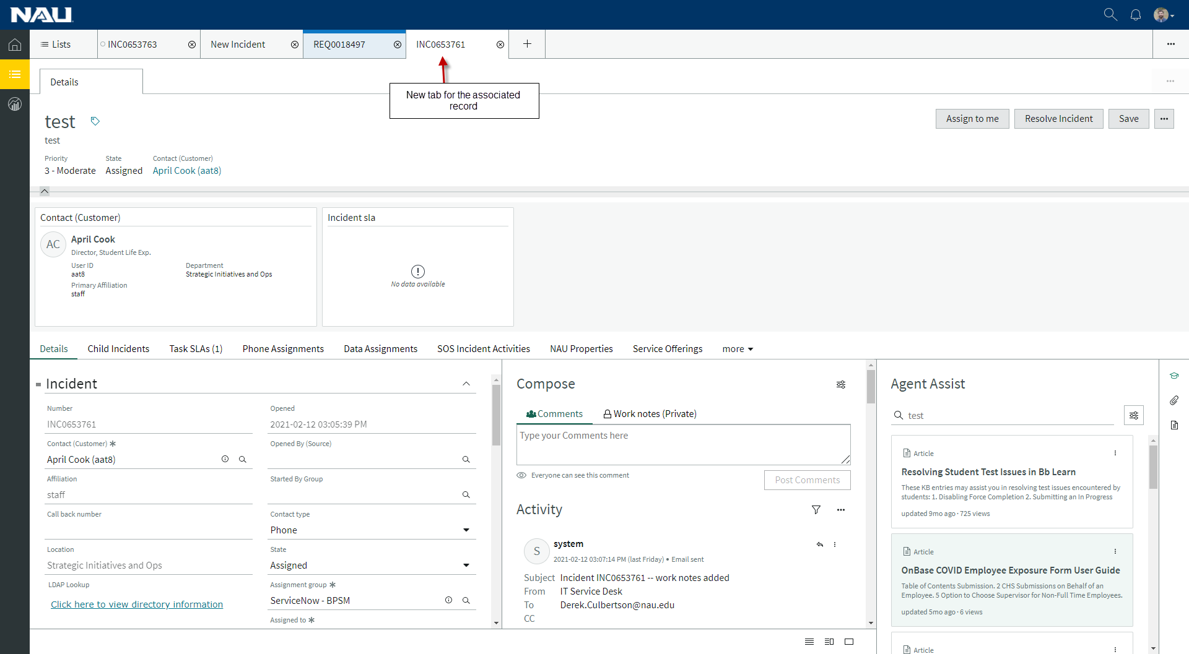

Notifications will also display in real time in the top right-hand corner of the screen.

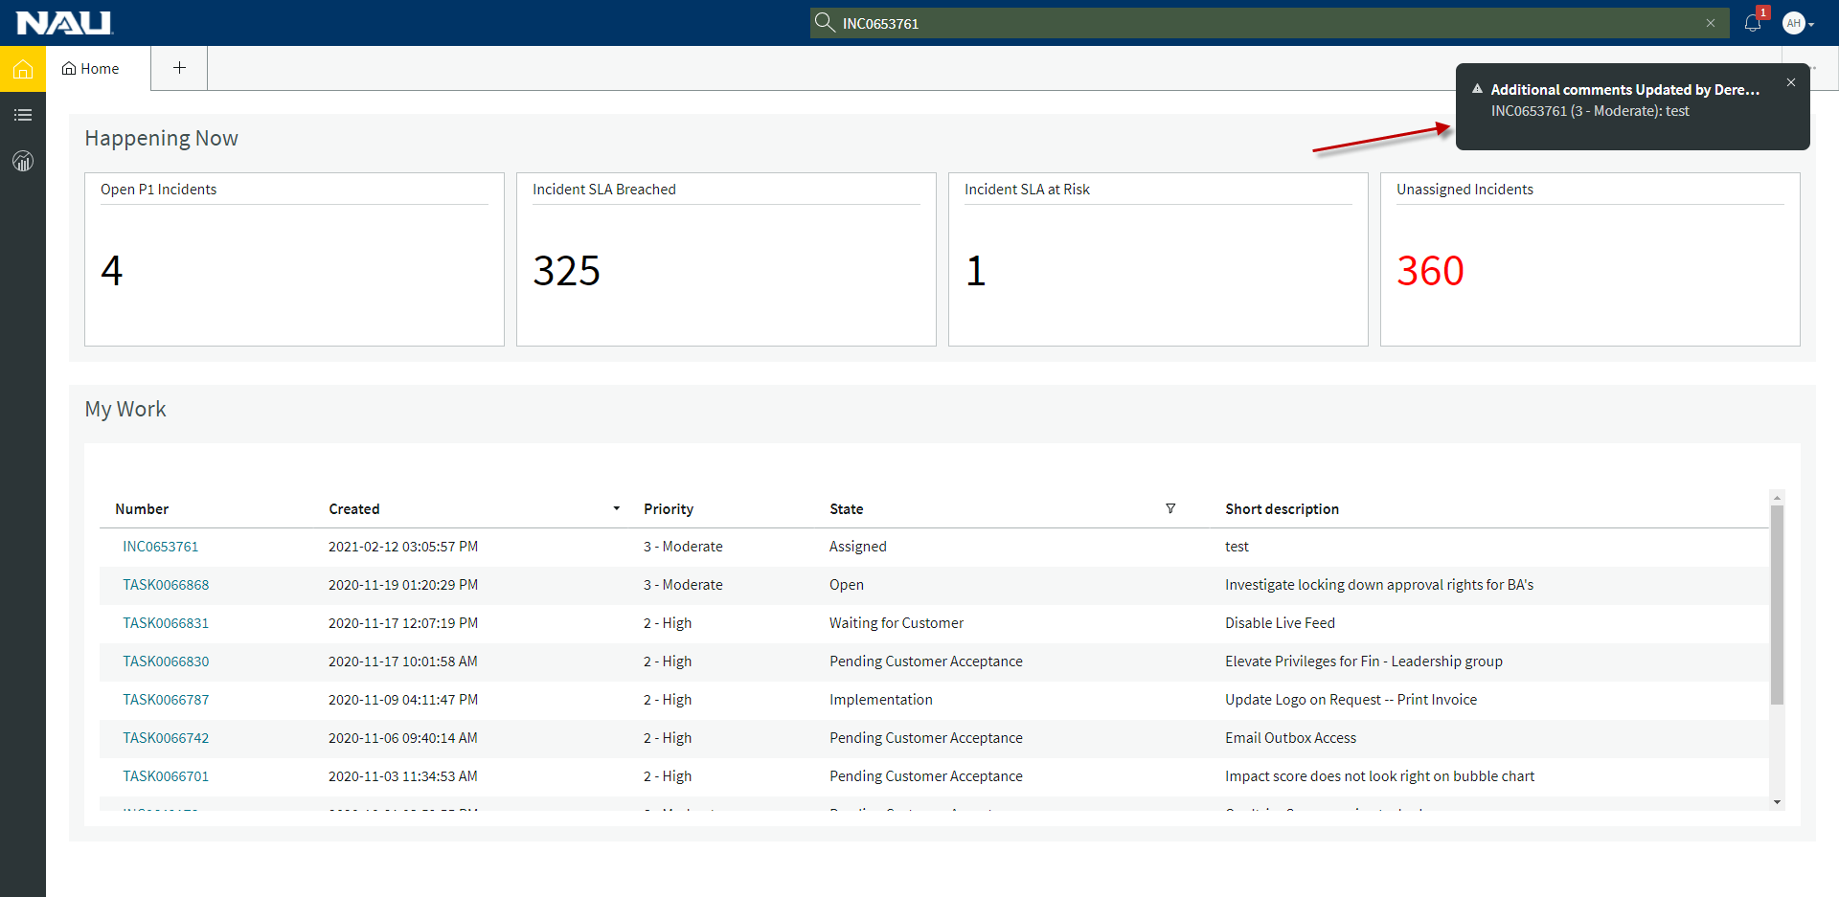

Notifications can be toggled on / off for both the Banner and Badge Count by clicking “Settings” under your user icon in the top right-hand corner of the ribbon.

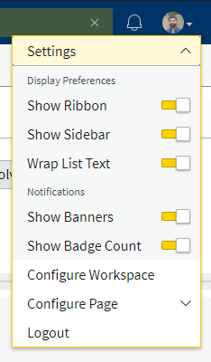

Agent Assist

Agent assist was created to help agents complete work quickly and identify trending issues. Agent Assist is on Incident records and can be used to search the Knowledge Base, Incidents, and Changes. Agent Assist will automatically search the short description of an Incident when it changes and display records that may be useful.

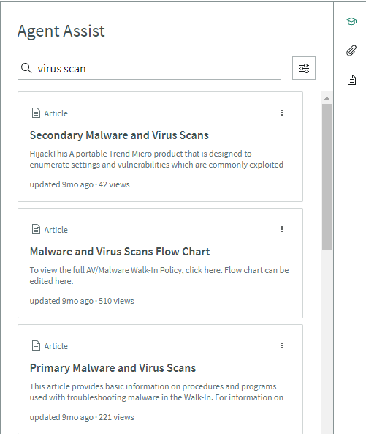

When you click on a KB article, it will be displayed in the Agent Assist windows

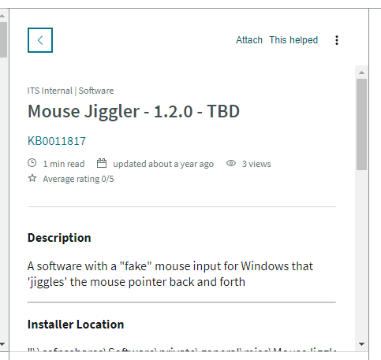

Click “Attach” to automatically add this KB to the incident, it will add a clink in the “Comments” and send that to the customer.

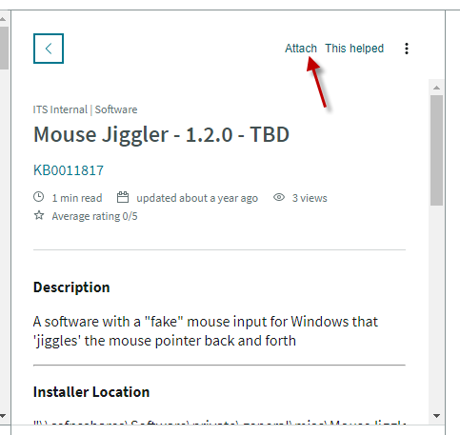

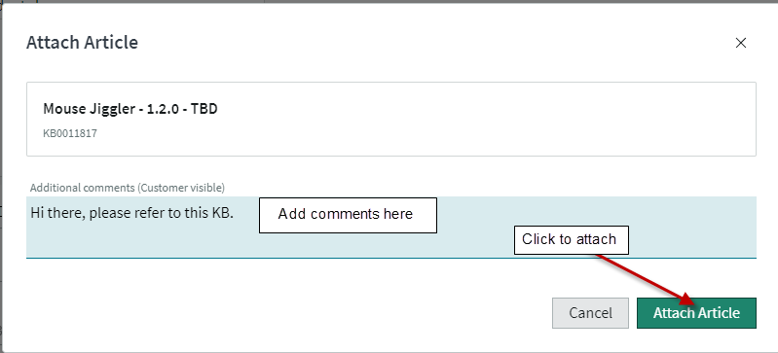

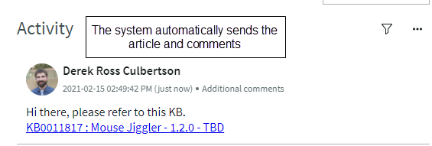

The “Search Resource” icon can be used to specify which records should be searched.

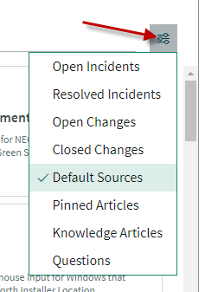

Select an Incident to open the details in the Agent Assist Window

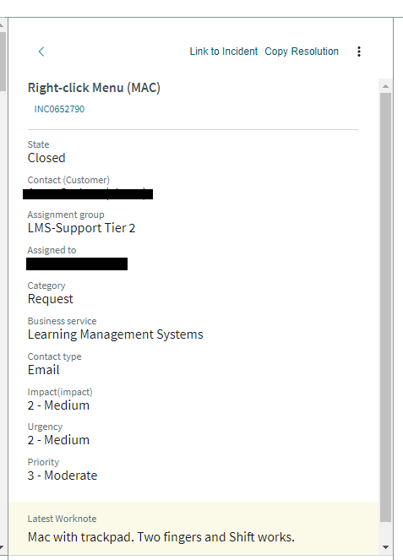

Use the “Copy Resolution” link to copy the resolution from the Incident open in Agent Assist to the Incident that is currently being worked. The system opens a modal window that allows you to edit the “Close Notes” prior to posting.

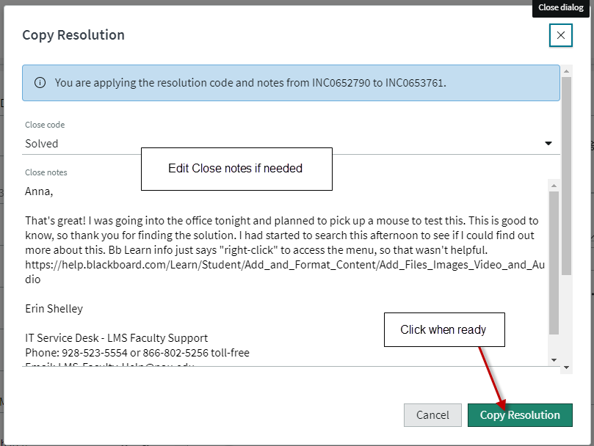

You can also click the Incident number to open the full incident details in a new sub tab

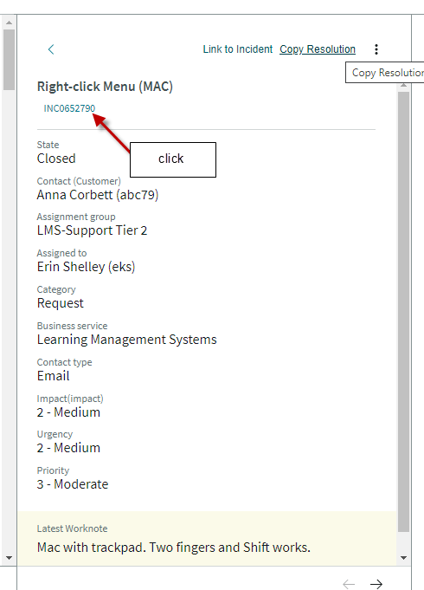

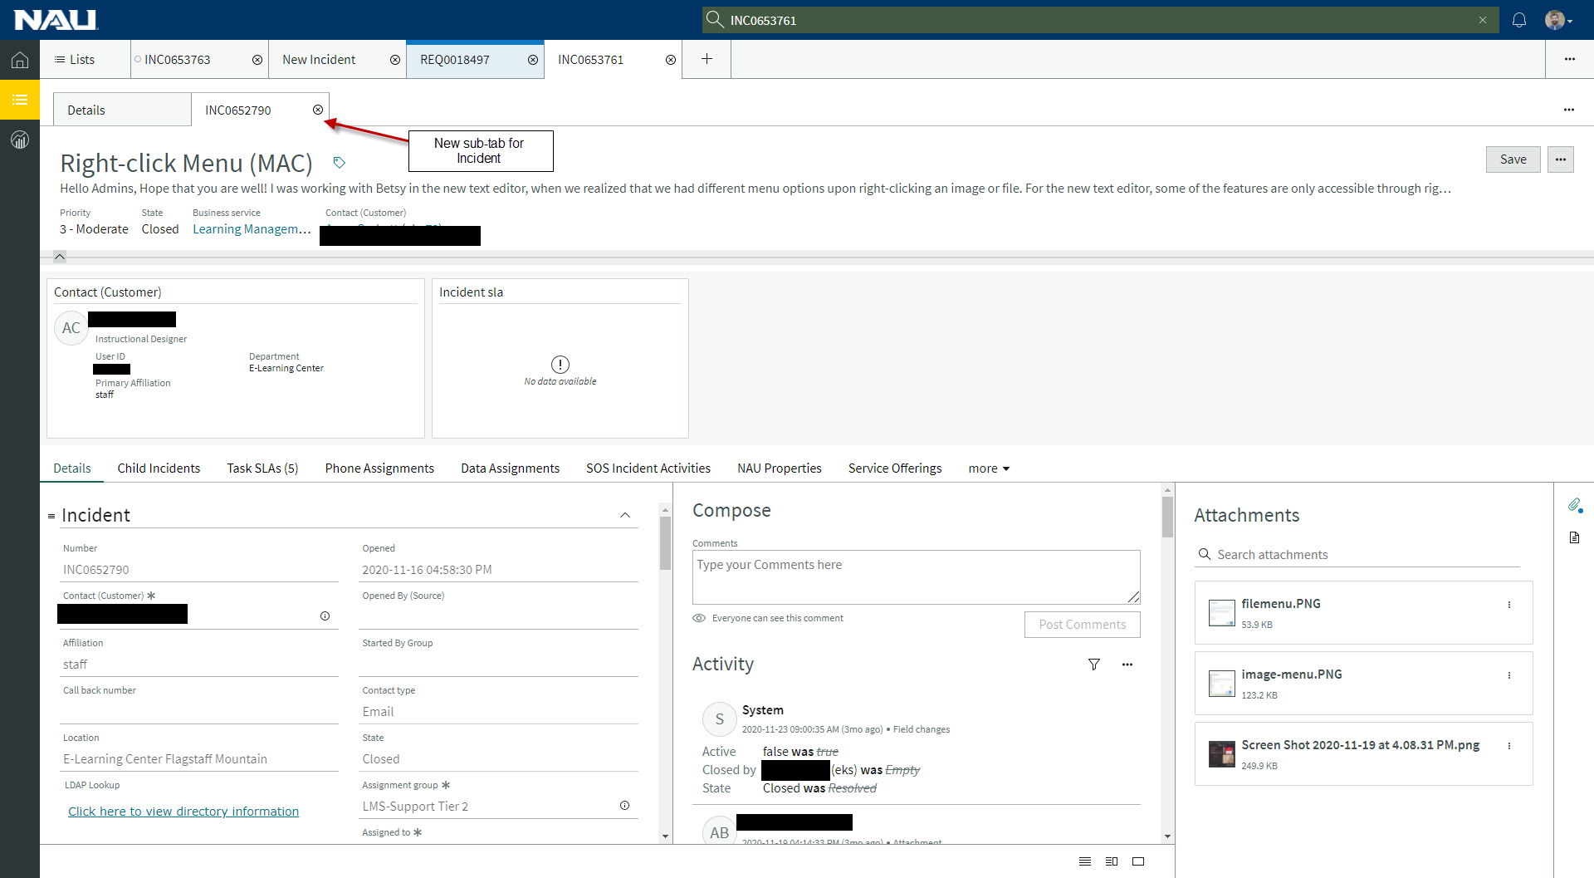

Custom lists

Shared lists are defined by system administers, however, users can create custom lists that fit their needs.

From the “Lists” menu, click “My Lists” sub menu, at the bottom select “+ New List”

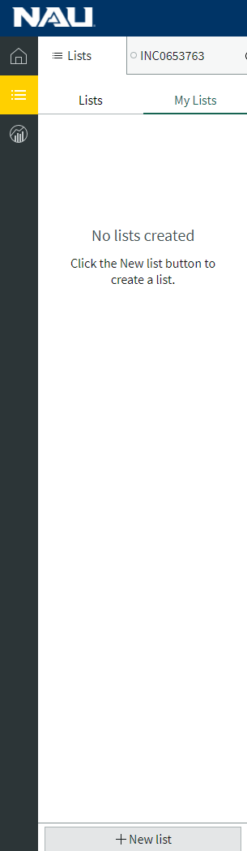

Fill in the Name, Table, Filter, and Columns that should be displayed, then click “Save”

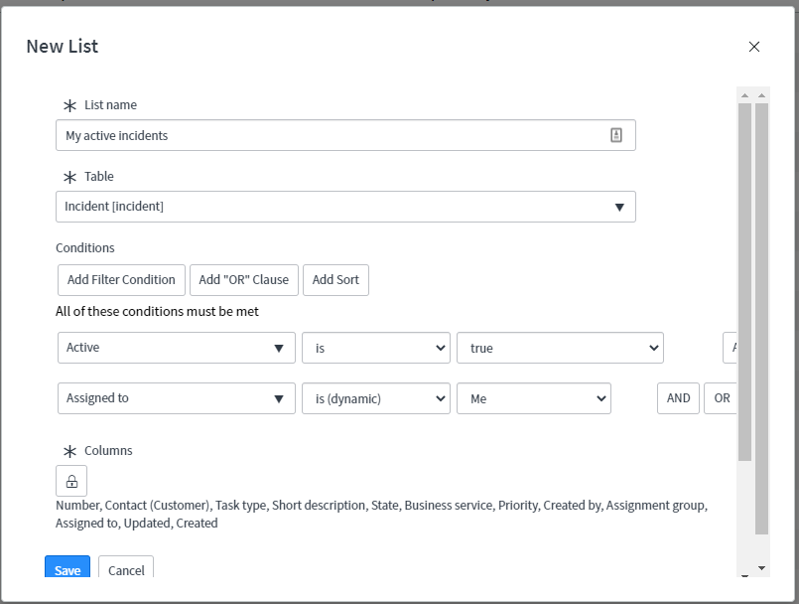

The new list now appears under My Lists

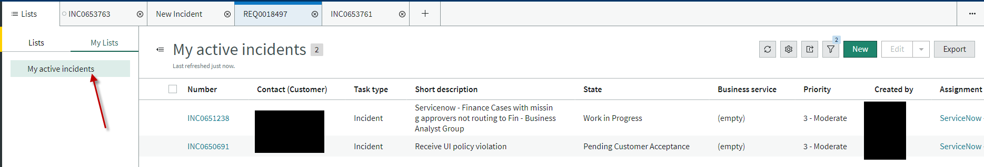

Other Resources

ServiceNow product documentation - <https://docs.servicenow.com/bundle/paris-servicenow-platform/page/administer/workspace/concept/service-workspace.html>

Resolving an Incident in Agent Workspace - <https://youtu.be/b04PwKqxD_o>

ITSM Agent Workspace | Incident - <https://www.youtube.com/watch?v=z2su-LkweJ4>